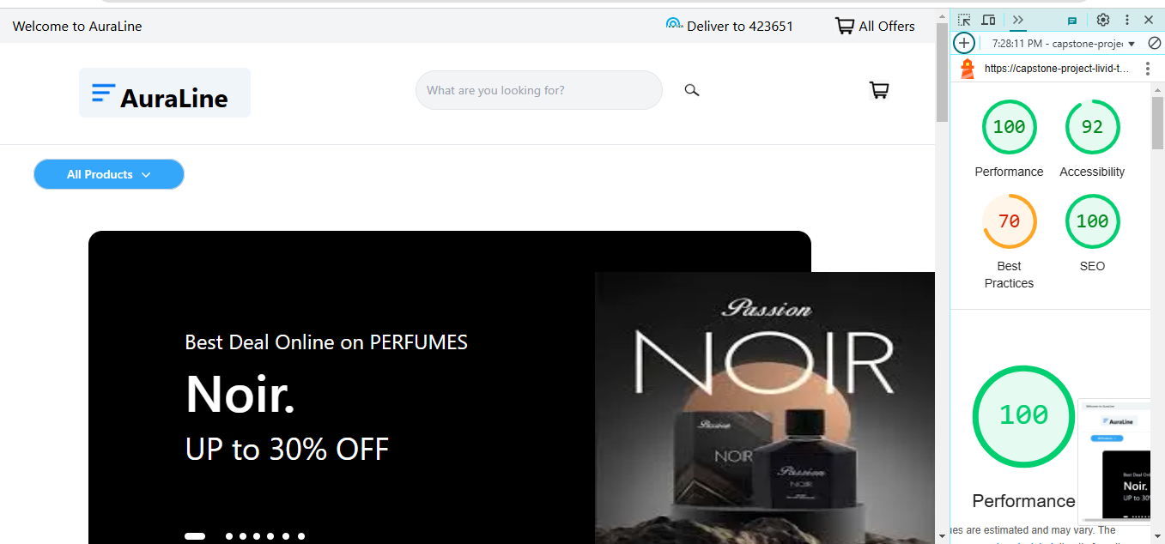

HOMEPAGE TESTING IN VERCEL

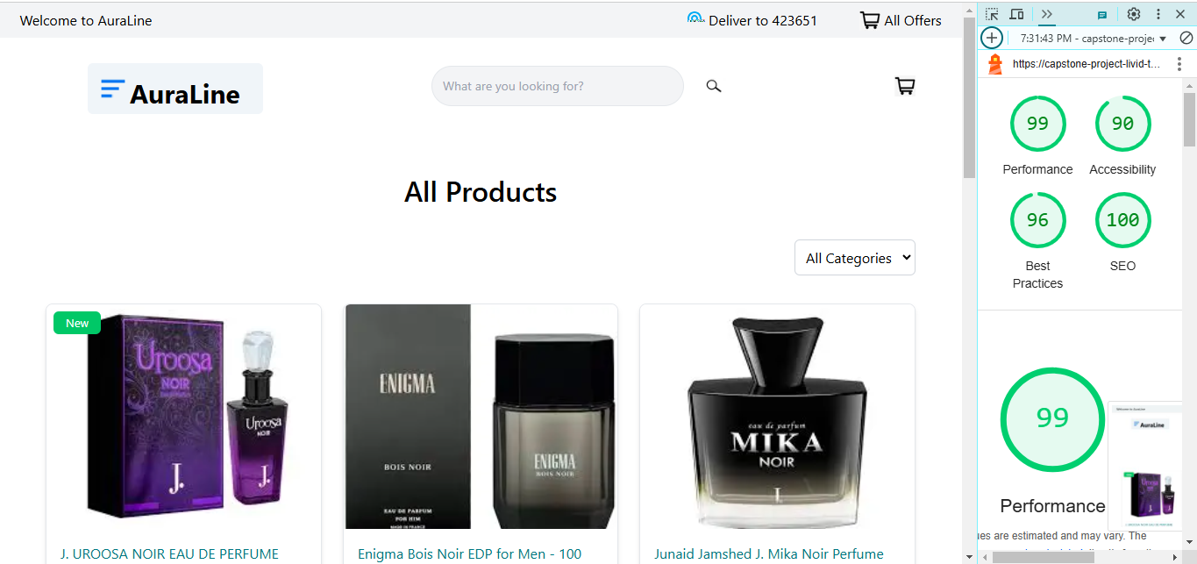

PRODUCT LISTING PAGE TESTING

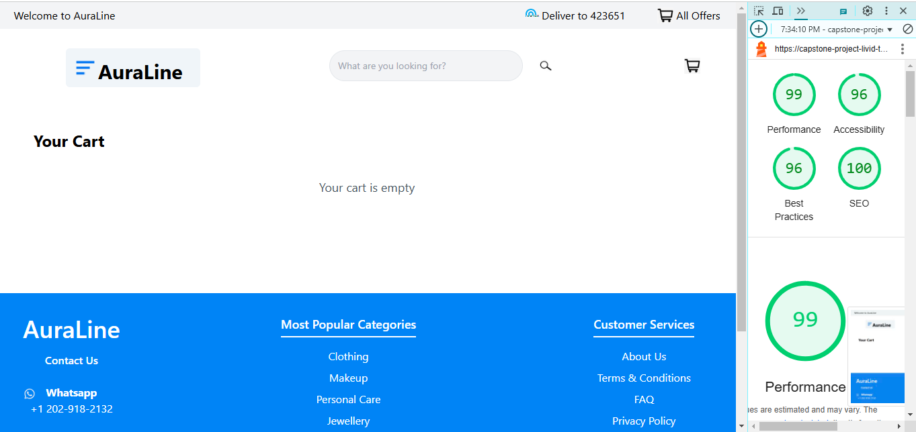

CART PAGE TESTING

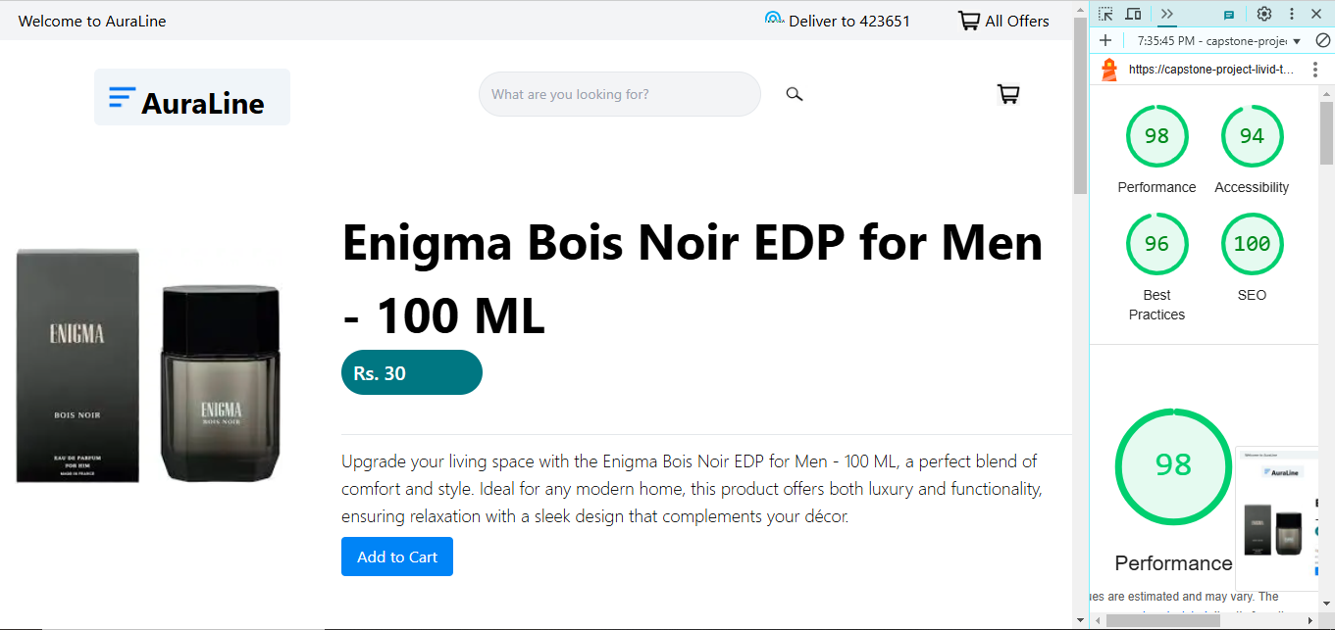

PRODUCT DETAIL PAGE TESTING